### Media for cultivation under various stress conditions

The media used for cultivation under stress conditions contained the following concentrations of inorganic ions: 50 mM K+; 100 mM NH4+, 52 mM SO42-, 50 mM PO42-, 2.03 mM Mg2+, and 50 mM of appropriate buffer. The salts used to obtain these concentrations varied depending on the buffer added: medium at pH 3 contained 6.6 g/L (NH4)2SO4, 6.8 g/L KH2PO4, 0.5 g/L MgSO4•7H2O and 7.5 g/L Tartaric acid (pKa 2.98); medium at pH 4.5 contained 7.1 g/L Na2SO4, 6.8 g/L KH2PO4, 0.5 g/L MgSO4•7H2O and 4.6 g/L Ammonium tartrate dibasic (pKa 4.25); medium at pH 5.5 contained 6.6 g/L (NH4)2SO4, 6.0 g/L NaH2PO4, 0.5 g/L MgSO4•7H2O and 5.1 g/L Potassium hydrogen phthalate (pKa 5.4); medium at pH 7 contained 6.6 g/L (NH4)2SO4, 6.8 g/L KH2PO4, 0.5 g/L MgSO4•7H2O and 5.2 g/L BES (pKa 7.1). Every medium contained 20 g/L glucose, 2 mL/L trace element solution and 1 mL/L vitamin solution. The growth of yeast strains was investigated in the presence of the following compounds at pH 5.5: Ethanol (11.4, 25, 45, 65, 78.6 g/L), 1,4-Butanediol (53.2, 60, 70, 80, 86.8 g/L), D-Limonene (4.9, 9, 15, 21, 25.1 g/L), 4-Aminobenzoic acid (PABA; 0.08, 0.25, 0.50, 0.75, 0.92 g/L); and at pH 3: Acetic acid (1.3, 2, 3, 4, 4.7 g/L), Formic acid (0.16, 0.30, 0.50, 0.70 g/L), Fumaric acid (0.48, 1.5, 3, 4.5, 5.2 g/L), Pyruvic acid (13.2, 20, 30, 40, 46.8 g/L), Ferulic acid (0.06, 0.19, 0.38, 0.57, 0.70 g/L), Succinic acid (13.2, 20, 30, 40, 46.8 g/L), Furfural (0.4, 0.83, 1.25, 2.5, 3.75, 4.6 g/L). A concentrated stock solution of each medium was prepared fresh the day before usage and the pH was adjusted using either NaOH or tartaric acid. The stock solution was filter sterilized and diluted using appropriate salt/buffer/glucose solution to yield different concentrations in the ranges indicated above.

### Inoculation of microplates and cultivation in the Growth Profiler 1152

Yeast strains were pre-cultivated as described above and harvested by centrifugation of the 24-deepwell microplates at 4°C and 4600 rpm for 10 min using a swing-out rotor. Spent medium was removed and cells were resuspended in 500-900 µL sterile water. Samples of the cell suspensions were diluted 10- and 20-fold and the OD values were measured in a 96-well microtiter plate using a Synergy H1 microplate reader (BioTek Instruments Inc., Winooski, VT, USA) at 600 nm wavelength. Each strain was then individually diluted in a 2 mL microtube to an OD = 4.5 (equivalent to a 1 cm light path length) and a volume of at least 1 mL. One cell suspension at a time was vortexed and poured into a liquid reservoir; using a multichannel pipette, 20 µl was inoculated in 6 wells on a 96-squarewell microplate (CR1496d, Enzyscreen, the Netherlands) containing 280 µL of medium, resulting in a starting OD of 0.3. The inoculation step was repeated for up to four microplates before the liquid reservoir was discarded and moving on to the next strain. The inoculated plates (up to 12 96-well microplates containing 912 experimental conditions) were then placed in the Growth Profiler 1152 and growth was monitored for ca. 66 hours. Evaluation of growth at temperatures 36°C, 38°C, 40°C, 41°C and 42°C was performed using 24-roundwell microplates (CR1424f, Enzyscreen, the Netherlands) containing 700 µL of medium at pH 5.5. These plates were inoculated with 50 µL cell suspensions at OD = 4.5, resulting in a starting OD of 0.3. Experiments at elevated temperatures were performed in biological duplicates and all other cultivations in at least three biological replicates.

### Processing of data generated by the Growth Profiler 1152

The G-values obtained from the Growth Profiler 1152 were converted to OD-equivalents prior to feature extraction from the growth curves. The calibration curve was generated by measuring the G-values of 24 cell suspensions with specific OD-values in the range from 0.2 to 95. These cell suspensions were obtained by concentrating the cells from eight cultures of yeast strain CEN-PK113-7D grown over-night in 25 mL YPD medium using 250 mL shake flask at 30°C and 280 rpm, and subsequently diluted appropriately to obtain the desired OD-values. The cell suspensions were used to fill the wells of both a 24-roundwell and a 96-squarewell microplate and the G-values were determined in all tray positions in the machine for both plate types. The G-values were averaged for each scanner and the SLM (Shape Language Model) toolbox for Matlab® was used to fit spline models to the data (one for each scanner and plate type). These models were used as the calibration curves for all experiments (Supplementary Figure 1?).

### Extraction of features from growth curves

Growth curves were analyzed automatically using in-house developed Matlab® scripts. From each growth curve, five growth parameters were determined: lag phase (defined as the time required to reach 25% of total number of generations), growth duration (defined as the time it takes to go from 25% to 100% of the total number of generations), number of generations during the growth phase (defined as (*ln*(OD*t* = end) - *ln*(OD*t* = lag phase)/*ln*(2)), average specific growth rate during the growth phase and maximum specific growth rate. Features were identified using spline models fitted to both linear and log-transformed data using the SLM toolbox. The average growth rate was calculated from the 1st derivatives of the log spline model within the specified time frame; the maximum specific growth rate was calculated by linear regression of at least four log-transformed data points. The outcome of the automatic feature detection was verified manually for each growth curve to ensure consistent results between biological replicates. Outliers were detected using a Hampel Filter and excluded from the data before analysis. The five growth parameters extracted from the growth curves were used to score the strains according to four physiological traits: Performance, Robustness, Conformance and Tolerance. The procedure for obtaining the scores in these traits and ranking of strains is described in Supplementary Note 1.

## Supplementary Note 1

### Definitions of physiological traits

|  |  |  |
| --- | --- | --- |
| **Trait** | **Comparison** | **Definition** |
| **Performance** | All strains | A strain with high performance has better values of the growth parameters than other strains at a specific inhibitory level. |
| **Robustness** | All strains | A strain with high robustness is able to perform better than other strains in all or most of the inhibitory levels. |
| **Conformance** | Individual | A strain with high conformance maintains or improves its own growth parameters in a specific inhibitory level relative to reference values. |
| **Tolerance** | Individual | A strain with high tolerance can grow and maintain its own growth parameters (relative to reference values) in all or most of the inhibitory levels. |

### Calculation of scores in the physiological traits

The starting point for the calculation is the data matrix containing the mean of the five growth parameter values extracted from replicate experiments. An experiment is defined by the strain and the level of inhibition (i.e. concentration for inhibitors and level for pH and temperature). The calculations are performed in the same way for each inhibitory condition and in this example it is assumed that there are six inhibitory levels in one specific condition. From the data matrix containing the mean values (228-by-5), the best parameter values are determined for each level of inhibition resulting in a 6-by-5 matrix. These best parameter values are then used to scale all corresponding parameters to a value between 0 and 20, where good values will be close to 20 and bad values will be close to zero (non-growing strains are given a score of zero in all growth parameters). This generates a new matrix of size 228-by-5 with Parameter scores, all in the range from 0 to 20. By summing up the Parameter scores in one inhibitory level, and for each strain, the Performance score is obtained. Since there are five parameters the range of the Performance scores is between 0 and 100. The matrix with Performance scores has the size 38-by-6, one score for each strain and in each inhibitory level. By calculating the average of the Performance scores for one strain over all inhibitory levels, the Robustness score is obtained. The range of the Robustness scores is also between 0 and 100. To obtain the Conformance and Tolerance scores, the initial scaling of the growth parameters is performed differently. Instead of selecting the best parameter value in each inhibitory level among all strains, the best parameter values are in this case chosen among all inhibitory levels for each strain individually. Hence, the matrix with best parameter values will be much larger (38-by-5) and represents the best values measured for each strain. By using these values to scale the corresponding parameter, each strain is only compared with itself and not to any other strain. Once the Parameter scores have been obtained, the Conformance and Tolerance scores are calculated as described above for the Performance and Robustness scores.

### Rank variability analysis (RVA)

The Robustness and Tolerance scores are useful for obtaining a general overview of the strains by ranking them according to descending property scores. However, such a ranking does not take into account the associated errors in the parameters. The most likely rank for each strain was estimated through random sampling of the probable space of the Performance and Conformance scores. For each strain and property (i.e. Performance or Conformance), 1000 random values were generated from a normal distribution with mean and standard deviation as calculated above. From these values 1000 scores of Robustness or Tolerance were calculate as described above for each strain. By ranking the strains according the Robustness or Tolerance scores (in descending order) an equal number of ranking values were obtained. As an example, histograms of the Robustness and Tolerance scores as well as the ranking values from the analysis of 1,4-Butanediol are shown in Figure SN1. This figure shows that the distributions of the ranking values are not always normally distributed which means that mean and standard deviation cannot be used to describe all the data.

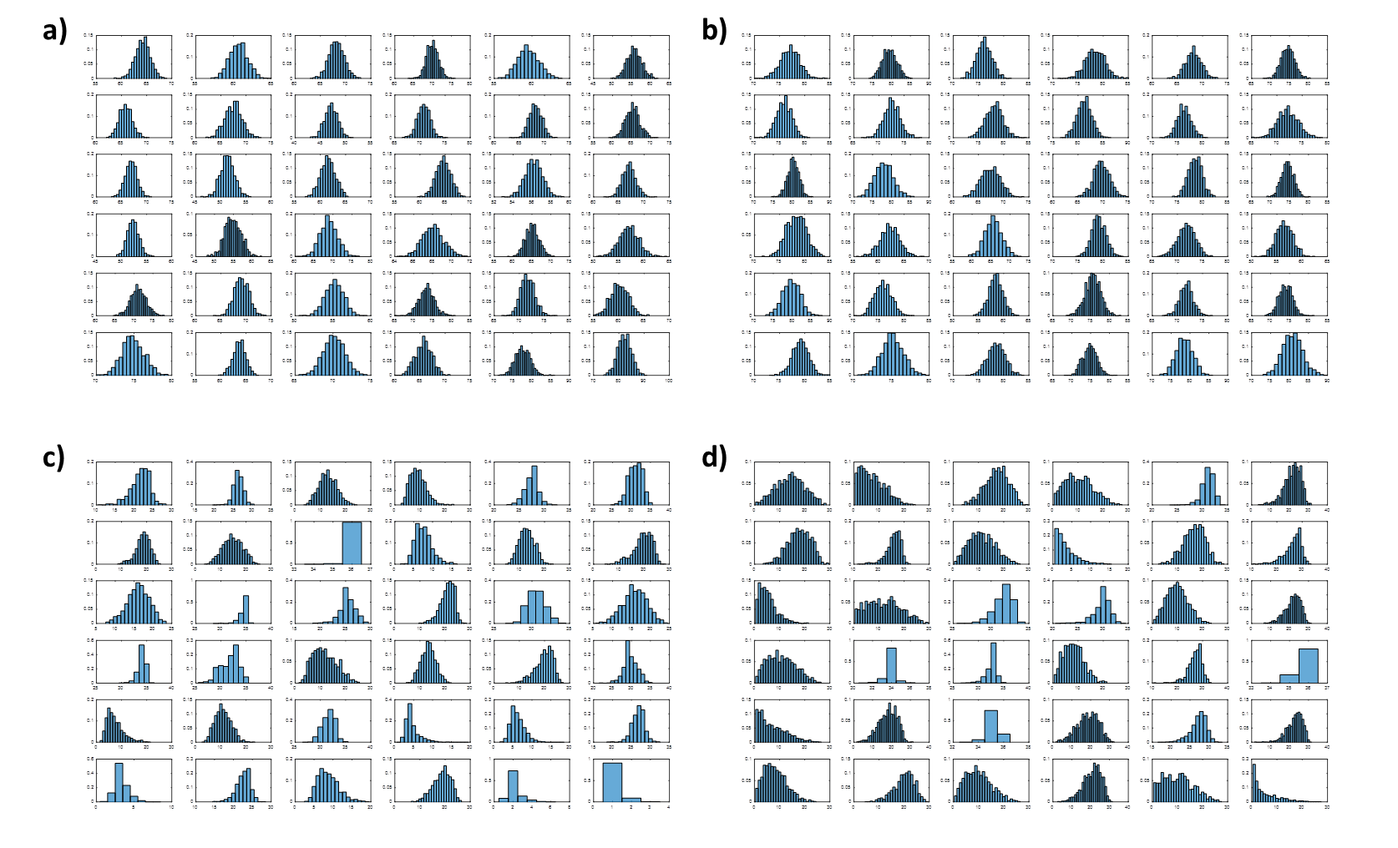

**Figure SN1. Distributions of property scores and ranking values from the analysis of 1,4-Butanediol.** Panels **a)** and **b)** show the distributions of Robustness and Tolerance scores, respectively, for all strains. The distributions of the associated ranking values are shown in panels **c)** and **d)**, respectively.

The property scores on the other hand are always normally distributed (Fig. SN1) and by fitting a normal probability density function (pdf) to the data, the mean and standard deviation can be estimated. The property scores are also normally distributed within each rank value (Fig. SN2) and hence, the mean score and the 95% CI can be calculated at each rank value. These values were used to i) estimate the most likely range of ranking values for each strain and ii) to build a pdf for the rank values for each strain. The most likely range of ranking values for each strain was estimated by determining within which ranking values the mean ± 1σ would fall given the 95% CIs associated with each ranking value. The generation of a pdf for the ranking values begins with estimating the probability of observing a score within the 95% CI associated with each rank value. This was done by integrating under the pdf fitted to the property scores within that interval. The pdf for the ranking distribution was then obtained by normalizing all 36 probabilities so that the sum equals to one (Fig SN3). By integrating under this pdf the probability for the raking range can be estimated, as well as the probability for each strain to fall within a rank of 10 and below a rank of 26 (i.e. within the top and bottom 10 strains, respectively).

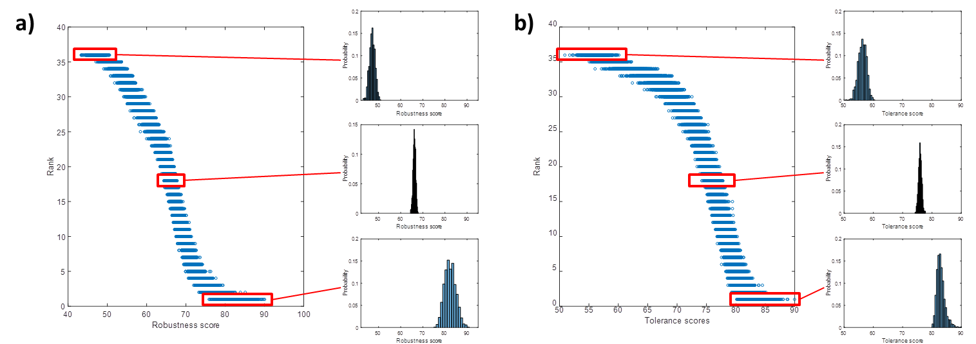

**Figure SN2. Distributions of property scores within rank values.** The distributions of Robustness **(a)** and Tolerance **(b)** scores are shown for ranking values 36, 18 and 1.

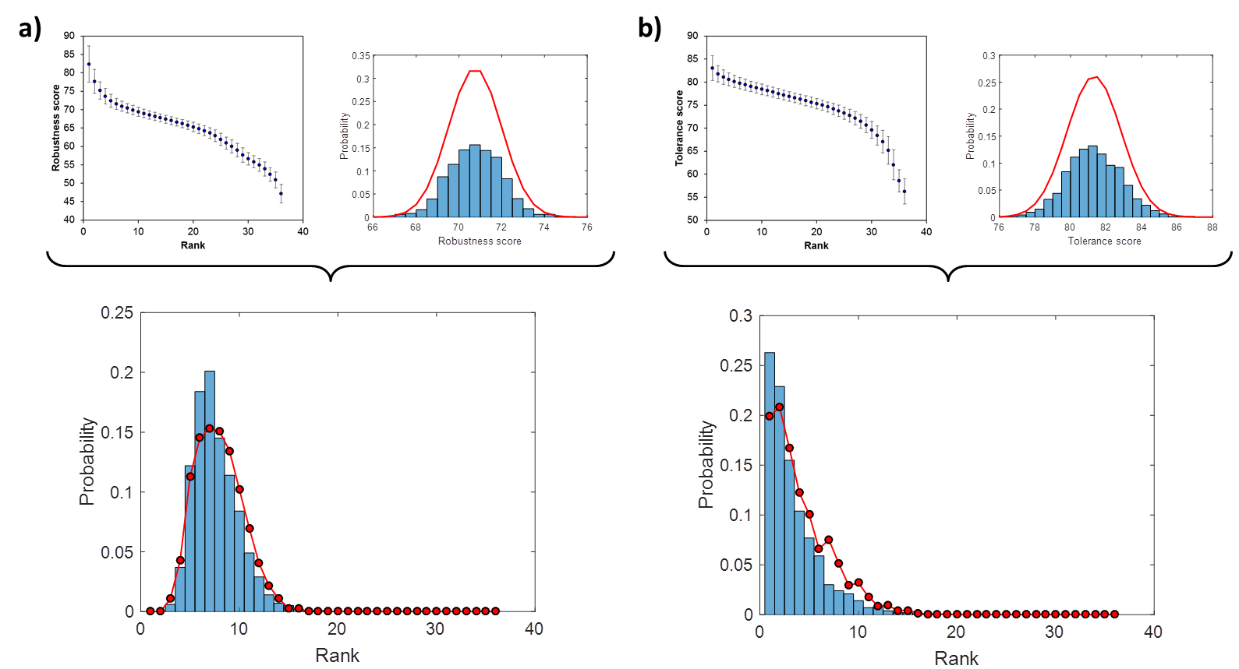

**Figure SN3. Estimation of a probability density function for the ranking values.** The probability of observing a property score within the range associated with each ranking value is estimated by integrating under the pdf fitted to the property score data for each strain. By normalizing the probabilities to sum to one, the probability for one strain to assume each ranking value is estimated. These values are plotted on top of the ranking distribution of Robustness **(a)** and Tolerance **(b)** for strain DBVPG1788 using data from 1,4-Butanediol experiments.

### Parameter influence analysis (PIA)

The scores obtained following the procedure described above should be considered as general scores since all the growth parameters are given equal weights. Hence, two strains can have the same general score even though they have quite different phenotypes. For example, if strains A and B perform equally in terms of average growth rate, but one excels in lag phase and number of generations whereas the other excels in growth duration and maximum growth rate, both strains would score the same despite very different phenotypic profiles. The influence of the parameters on the ranking of the strains was assessed by performing a RVA at different weights for the parameter of interest. The parameter weights increased from 0 (i.e. the parameter is not used in the calculation of the scores and hence not taken into account when ranking the strains) to 5 (i.e. the scores and the ranking are based solely on the current parameter) with an increment of 0.1 in every iteration. The other parameters were given equal weights such that the total sum of all weights equaled five. For example, if the weight for parameter 1 was set to 3, the other four parameters were all given (5-3)/4 = 0.5 as the weight. The result can be represented as a plot of mid rank value against the parameter weight for all the parameters (Fig. SN4). Each series is normalized to start at the origin and the influence can be quantified as the area under the normalized values. This area has the following characteristics: i) if the rank value is unaffected by the parameter the area will be close to zero, ii) if the rank value tend to increase with increasing parameter weight the area will be large and positive and iii) if the rank value tend to decrease with increasing parameter weight the area will be large and negative (Fig. SN5). The parameter influence score is given as the negative value of the area. Hence a positive score means that there is a positive effect on the ranking position of the strain (i.e. the ranking value decreases) and a negative value means that there is a negative effect on the ranking position (i.e. the ranking value increases).



**Figure SN4. Dependency of the mid rank value on the different parameters.** The Parameter Influence Analysis is based on independent evaluations of each growth parameter. A RVA is performed at different weights for the parameter of interest to estimate its influence on the ranking. The figure shows the evaluation of DBVPG1788 in 1,4-Butanediol with regard to Robustness **(a)** and Tolerance **(b)**.



**Figure SN5. Quantification of parameter influence.** **a)** Each parameter series is normalized to start in the origin. The area under these normalized values represent the influence that each parameter has on the ranking of a strain. The figure shows the normalized ranking values and the corresponding area for three parameters with different influence on the ranking of DBVPG1788 in Robustness towards 1,4-Butanediol. **b)** The parameter influence scores are the negative values of the area and are shown for Robustness and Tolerance of DBVPG1788 in 1,4-Butanediol.